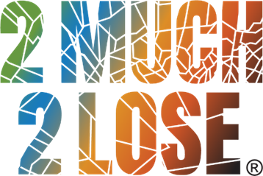
2M2L Law Enforcement Training Agenda
7.25 CLEET hours
Date: April 17th, 2024
Location: Oklahoma Sheriffs’ Association - 1615 South State St., Edmond, OK 73013
8:30 – 9:00 Registration/Pre-Survey
9:00 – 9:30 General Session: Welcome and Introductions
9:30 – 11:30 Alcohol Laws (Captain Smoot)
This session will discuss Oklahoma’s alcoholic beverage laws. Especially those intended to
reduce underage drinking through limiting youth access to alcohol.
11:30 – 12:30 Lunch on your own
12:30 – 1:30 Alcohol Laws continued (Captain Smoot)
1:30 – 3:00 Alcohol Compliance Checks/Bar Checks and Special Event Techniques (Captain Smoot)
This session will address the development and environmental factors that contribute to
drinking patterns within the normative group of adolescents or will focus on the assessments
and bar checks of on-sale establishments or special events where alcohol is sold to prevent
underage access and adult over-service to meet state statute requirements.
3:00 – 4:30 Fake & Altered IDs (Captain Smoot)
The session will discuss how law enforcement officers or private citizen stakeholders can
recognize fake and/or altered IDs. Alcoholic beverage and other criminal codes used to
prosecute users of fake or altered IDs will also be discussed
4:30 – 5:15 Controlled Party Dispersals (Captain Smoot)
This session will describe teen parties and explain why they are one of the highest-risk settings
for alcohol- related problems among youth.

