  - Description:
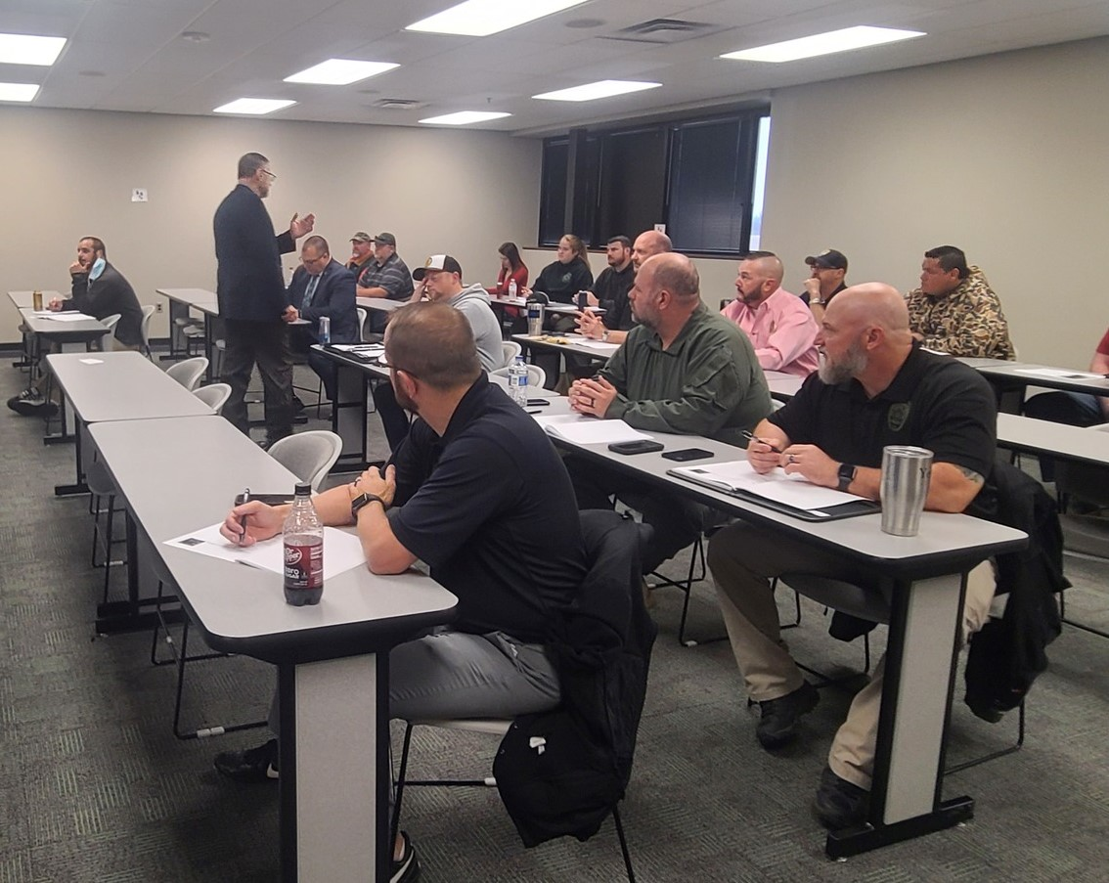

Date:
April 11-12, 2022

Two Day Training

Time:
0800-1700

CLEET Hours:
16

Location:
Oklahoma Sheriff’s Association
Training Room
1615 South State Street
Edmond, OK 73013

CLEET Catalog Number:
21-0813

Max Capacity: 40

A comprehensive look for supervisors to improve output and performance, create a positive work environment for subordinates and improve leadership. Taught by creator and author Earl Morrison, Assistant Director of CLEET.
To Register: Email Alysha Maxwell
Alysha.maxwell@cleet.state.ok.us

